Practical-06 OS

Q1. Write a shell script which accepts a number and displays the list of odd numbers below that number. It should also display the sum of all this odd numbers.

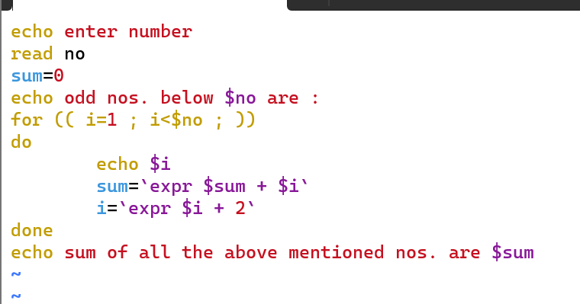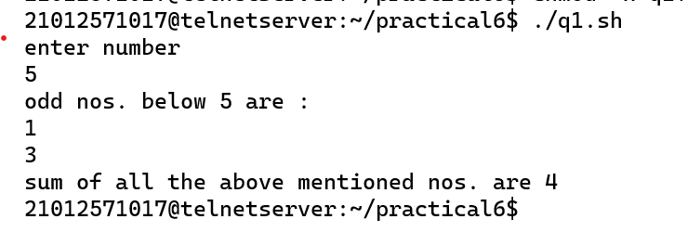

Q2. Write a shell script to arrange numbers in ascending or descending order as per the user choice.

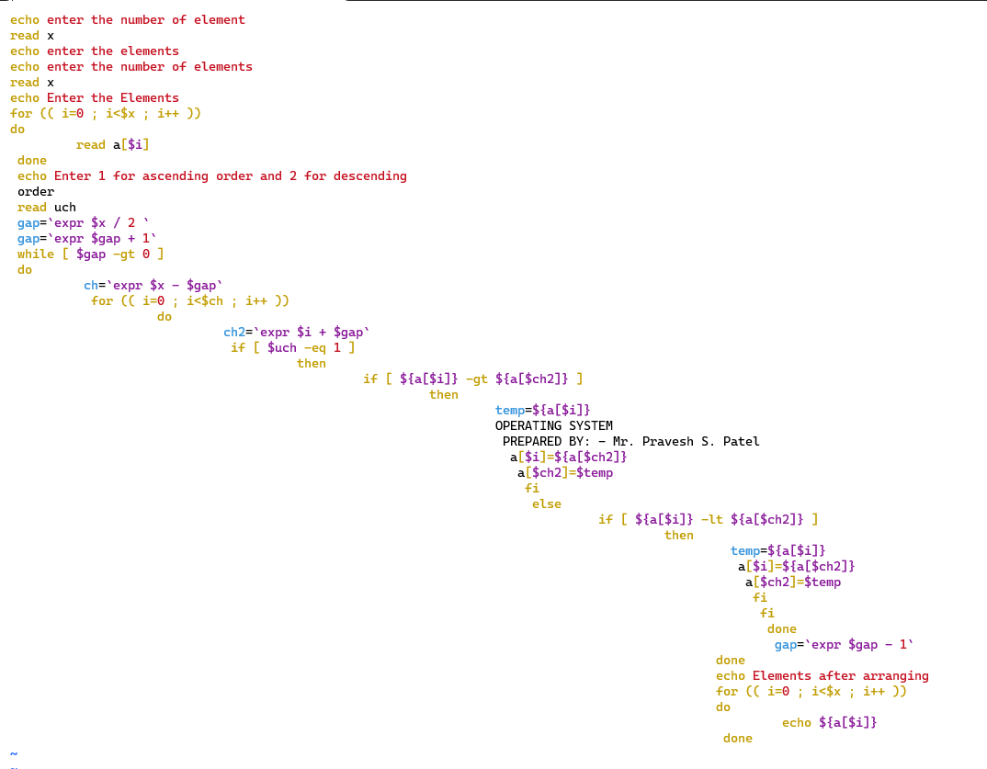

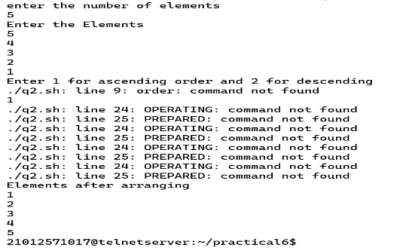

Q3. Write a shell script to check whether the entered number is Armstrong or not.

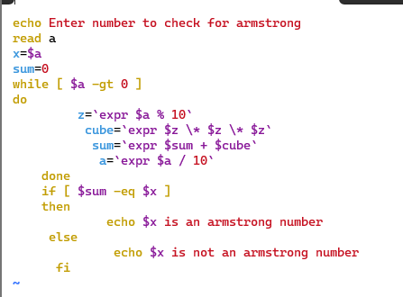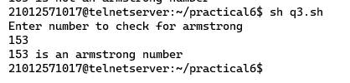

Q4. Size of array A is 10 while size of B is 30. Scan 10 integers in both the array and concat array A to B. Then apply sorting algorithm according to the user choice.

Q5. Write a shell script to remove duplicates values from an array.

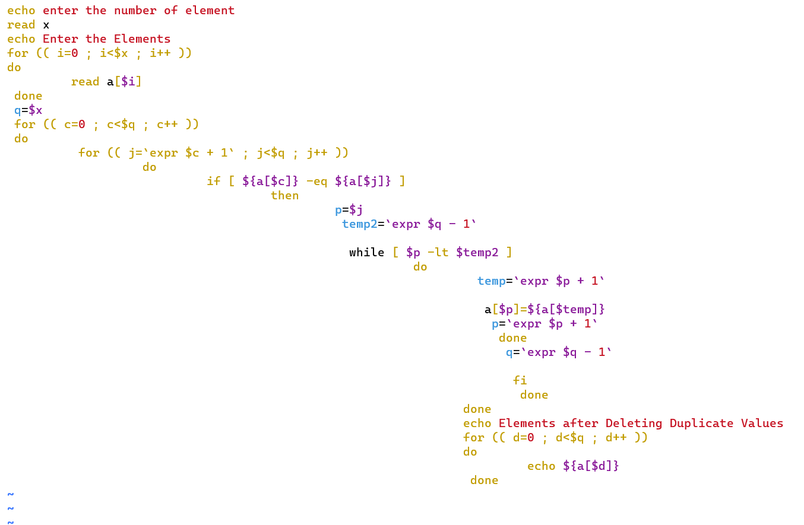

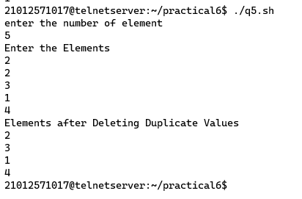

Q6. Write a shell script to add two arrays.

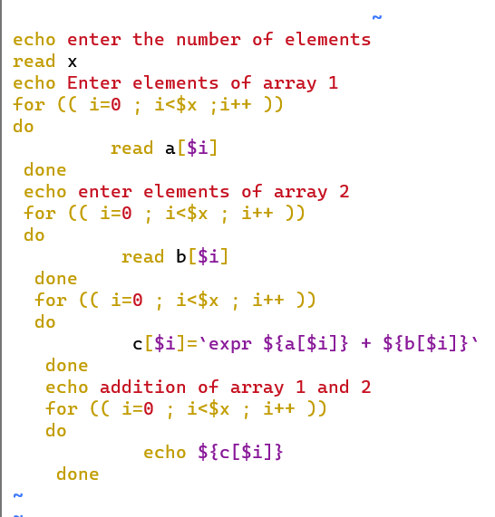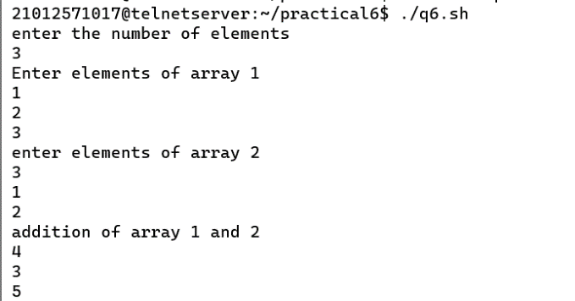

Q7. Write a shell script to reverse an array.

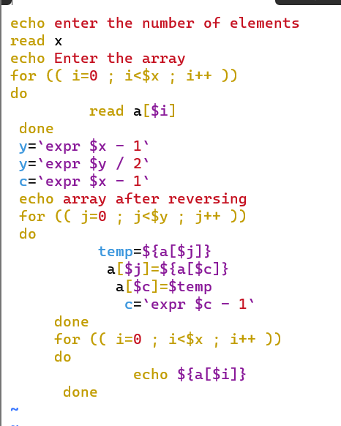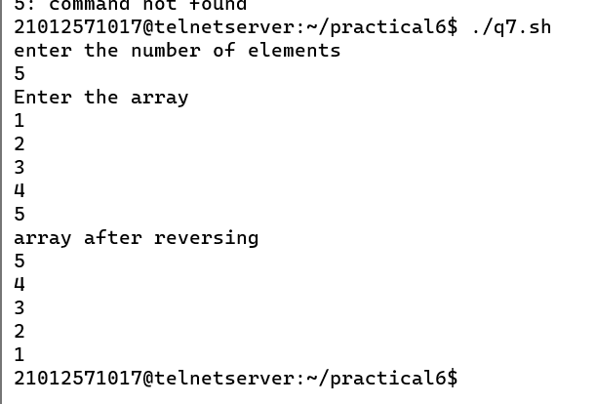

Q8. Write a shell script to convert upper string is in lower case string.

